Task -01
You should spend about 20 minutes on this task.
The bar chart below shows shares of expenditures for five major categories in the United States, Canada, the United Kingdom, and Japan in the year 2009.
Summarise the information by selecting and reporting the main features, and make comparisons where relevant.
Write at least 150 words.
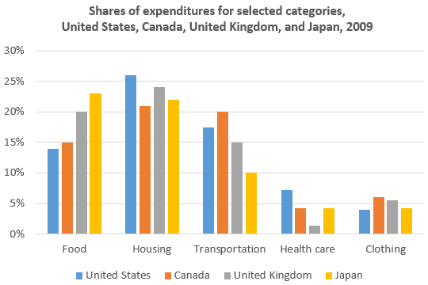

Task-02
You should spend about 40 minutes on this task.
Natural resources such as fresh water, oil and forests are disappearing from Earth. Why is this happening? Is that dangerous? Suggest a solution for this problem.
Give reasons for your answer and include any relevant examples from your own knowledge or experience.
Write at least 250 words.

Task-01
You should spend about 20 minutes on this task.

A friend wants to get some information about an elementary school where one of your cousins studies.
Write a letter to this friend. In your letter,
- say why this school is a good elementary school
- mention how expensive it is
- explain why your friend should get his/her child admitted there
Write at least 150 words.
You do NOT need to write any addresses.
Begin your letter as follows:
Dear ......................,

Task-02
You should spend about 40 minutes on this task.

Natural resources such as fresh water, oil and forests are disappearing from Earth. Why is this happening? Is that dangerous? Suggest a solution for this problem.

Give reasons for your answer and include any relevant examples from your own knowledge or experience.
Write at least 250 words.

